Hakan COŞKUN

Adress : Yeditepe Üniversitesi Kayışdağı
E-mail : hakan@hotmail.com
GSM : 0541000000
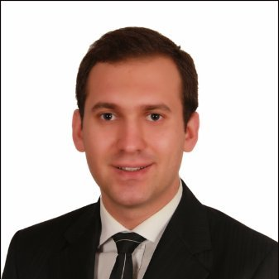

EDUCATION
09.2007 – Present Yeditepe University - IT, English
(50% Success Scholarship CGPA: 3.37 )

09.2007 – Present Yeditepe University - Food Eng, English (Minor)
(100 % Success Scholarship CGPA: 3.37)

06.2016-08.2016 EF Language Intensive School ( Florida, USA)

09.2001 – 06.2005 Hacı Ahmet Atıl High School

EXPERIENCE
02.2012 – Present Yeditepe University, Career & Alumni Manager,Full time
*
*
*
08.2008 – 11.2008 Koç Holding, Marketing Intern
*
*
LANGUGE SKILLS
English : Upper Intermadiate (Fluently) IELTS :6
Chiness : Intermadiate

COMPUTER SKILLS
MS Office Programs, Adobe Photoshop

PROJECTS
2012 TEGV jsgdhhasgkhadhg
*
*

SEMINARS

2012 Sport’s Nit. – Cerrahpaşa Med. Group Doç Dr. Çiğdem AKTUĞLU ZEYBEK

MEMBER OF CLUBS
2015 Sanitas Club

HOBBIES
Yeni diller,Networking with my business area, Moda Tasarım, Girişimcilik, Mozaik ve Gravür teknikleri ile resim yapma

REFERANCES
Duygu HALİFEOĞLU Yeditepe Üniversitesi, Career& Alumni Manager
GSM: 0532000000 / E-mail: duygu@hotmail.com

PERSONAL INFORMATION

Date of Birth :
Place of Birth :
Nationalty :
Driving Licance :
Military :

